GA-400 Toll Robbery

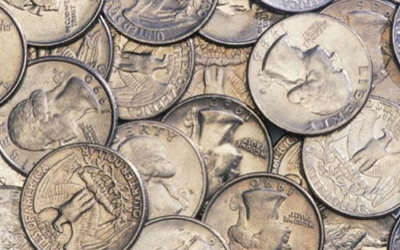

Earlier this morning a man held up a GA-400 toll booth. His stolen getaway car broke down and he is now on the run with a 58 lb. bag of quarters.

