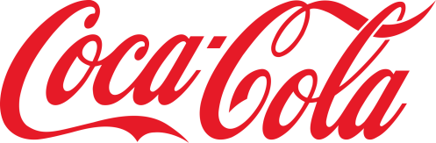
Display Project

You will create your own display for the Coca-Cola merchants to use for a specific holiday, event or sports team. You will explain how many of each 12 pack are required for the display, what the height and width of the display will be ( so the merchant can determine the best location for the display) and you will have a color coded design for the delivery person to use to construct your display.
Remember that the 12 packs are displayed with ends showing and stacked one atop each other. There can be no spaces underneath. The top may be arced or pointed somewhat.
Here is the color code for the Coca-Cola products manufactured by your bottling company.
Red | Coca-cola | Blue | Sprite zero
Orange | Fanta | Reddish-purple | Coca-Cola Vanilla
Yellow | Mello-Yello | Black | Coke Zero
green | Sprite | Silver | Diet Coke

Use the chart on the back of this sheet to create your design. Color it using colored pencils.
A 12 pack measures
List the number of each brand of soda 12 pack needed, the height and width of your display and any other needed information for your vendor. Other information for vendor would be if sodas will be pulled out slightly or pushed back to add dimension to the display or if other accessories would help promote the holiday or event I e balloons, lawn chairs, etc.

Number of 12 packs required
Coca-cola |  | Sprite zero
Fanta |  | Coca-Cola Vanilla
Mello-Yello |  | Coke Zero
Sprite |  | Diet Coke

Dimensions of display

Other information needed for vendor

